
College of Business

Master of Business Administration Program
Master of Human Resource Management Program

MGT523 Strategic Management in a Global Environment
Fall Semester AY2018-2019

Group Project (GP)
Team Number | Group 3
Students Names | Yaqoob Alshamsi, Saud Alqaydi, Asma Alhosani,  Anood Aljneibi
Student ID No. | 1062148, 1064000, 1063248, 1063248, 1064126
Course Code and Title | MGT523 Strategic Management in a Global Environment
Course Instructor | Dr. Avraam Papastathopoulos
Course Section | AD_S2
Group Project Submission | Soft copy on Blackboard AND hard copy should be submitted to my office by Monday, December 5th at 5:00 PM
Assignment Type | The project is worth 30% of the total grading

Marking Scheme:
Sections | Sub-Sections | Points | Score | CLO | PLO
Executive Summary |  | 1
Analyzing firm’s past performance and issues | Firm and industry performance | 2 |  | 2 | MBA_PLO1
Analyzing firm’s past performance and issues | External analysis | 2 |  | 2 | MBA_PLO1
Analyzing firm’s past performance and issues | Internal analysis | 2 |  | 2 | MBA_PLO1
Analyzing firm’s past performance and issues | Critical assessment of strategy | 2 |  | 3 | MHRM_PLO3
Analyzing firm’s past performance and issues | Key lessons learned from the past | 2 |  | 3 | MHRM_PLO3
Identifying current issues | Defining the current issue(s) and problem statement | 2 |  | 3 | MHRM_PLO3
Identifying current issues | Analyzing information | 2 |  | 4
Identifying current issues | Generating alternatives | 2 |  | 4
Recommended Strategies, Evaluation & Control | BLS, CLS, Green Strategies, KPIs, Balanced Scorecard, etc. | 9 |  | 5 | MBA_PLO5 & MHRM_PLO4
Conclusion |  | 2
Bibliography-References-Appendices |  | 2

ــــــــــــــــــــــ
100

ــــــــــــــــــــــ
30

Total Points or Percentage: or

General Instructions

Please read the instructions below. Failure to comply with the instructions will result in a penalty ranging from 5% to 100% of the grade

- Use this document as a template for your response. In other words, type your student information and your answers into the document.

- The GP can be undertaken in teams of 4 to 5 participants depending on the total number of students enrolled for the course at one time.

- Your answers must be based on the company you have selected to analyze.

- Please use Times New Roman, font size 12 and a line spacing of 1.15

- The length of this project should be up to 30 pages (maximum) 1.15 spaced (Including the three cover pages!!!)

- Please DO NOT USE a comb, wire or coil binding. Also, DO NOT STAPLE your assignment in the top left corner only. Put your assignment in a plastic folder.

- No plagiarism please [100% penalty + referral to the OAI]

“Plagiarism, the act of taking the writings of another person and passing them off as one’s own. The fraudulence is closely related to forgery and piracy-practices generally in violation of copyright laws.”
Encyclopedia Britannica

  - If you use text from the textbook/case study, please make sure you paraphrase it in a way that fits with your overall discussion. Please put an appropriate citation to make it explicit that you are using information from the sources. If you think the text fits into your discussion without paraphrasing, please cite it in a way that makes it clear that this is a direct quote (e.g., indent a paragraph containing text or put a sentence in quotes)

  - Do not use information from the Internet to answer any of the questions (your company’s official website, annual report and financial statements are accepted). Please use your own thinking/writing to answer the questions.

  - To avoid plagiarism, all you need to do is to reference every information taken from other sources.
  - Students found guilty of plagiarism will be prosecuted in accordance with the ADU Academic Integrity Policy

- No points will be given for responses that [up to 100% penalty]

  - Cannot be understood
Please make sure every paragraph conveys a coherent unit of thought. No points will be given for paragraphs which are, in essence, a random compilation of somewhat related ideas from various sources.
  - Are not backed by evidence
Use evidence from the annual report, financial statements and web site of your company to support your claims
  - Are not related to the case study
All of your responses should be related to your chosen company.
  - Do not answer a question
No points will be given for responses that do not answer a question but contain information about issues/terms related to the question. This type of response is usually given in hope to receive partial credit

Table of Contents
1 Introduction 5
1.1 Summary 5
Phase 2: Analyzing Firm’s Performance and Issues 6
2.1 Firm and Industry Performance 6
2.2 External Analysis 8
2.2.1 PESTEL 8
2.2.2 7 Forces 12
2.3 Internal Analysis 14
2.3.1 Resources 14
2.3.2 Capabilities 15
2.3.3 VRIO 15
2.4 TOSW Analysis 18
2.5 Critical assessment of Strategy 22
2.6 Key lessons learnt from the past 30
Phase 3: Defining the Current Issue(s) and Problem Statement 32
Phase 4: Analyzing Information 34
Phase 5: Generating Alternatives 35
Phase 6: Recommended Strategies, Evaluation & Control 36
6.1 Business Level Strategies 36
6.1.1 Cost Leadership 36
6.1.2 Differentiation 37
6.1.3 Focus 37
6.2 Corporate Level Strategy 38
6.2.1 Diversification 38
6.3 Green strategy 38
6.4 KPI and Balance Scorecard 39
Phase 7: Conclusion, References & Appendices 40
7.1 Conclusion 40
7.2 References 41

1 Introduction

1.1 Summary

UAE Exchange was created in the year 1980. The organization has over thirty-five years of existence since its formation. It is a financial institution operating under the Financial Services and Insurance Industry. The organization has since expanded into one of top global remittances, foreign exchange as well as payment solutions brand worldwide. The firm is headquartered in Abu Dhabi. However, UAE Exchange is current present in thirty-one countries in five continents. It has around eighty-hundred branches. The organization is mostly dominant in the United Arab Emirates where it owns nearly one-hundred and fifty branches spread across the 7 Emirates. It has seventeen branches in Dubai metro stations.
The brand creates a competitive edge through its focus on customers. It is driven by people, product and process. “Going that extra mile” remains a tenet that drives the organization to be liked by customers. Through this principle, the organization has been able to provide its clients with tailored and prompt services based on each client’s needs financially. The organization arranges for several promotions at each branch alongside social media podiums. Such promotions are used to reward its clients for their endless patronage. The brand’s service portfolio comprise of foreign exchange, bill payments and money transfer.
The firm’s workforce is more than 9000 professionals with over forty nationalities. The workforce has always strive to accomplish excellence and ensure delight to over fifteen million clients and customers globally. The organization has a strong correspondent banking linkage with more one-hundred and forty international banks alongside smart technology all of which are adding to its superiority. UAE is the broadest internationally networked brand for remittances. Its quality services have received recognition and rewards.

Phase 2: Analyzing Firm’s Performance and Issues

2.1 Firm and Industry Performance

The UAE Exchange ranks in the top 3 most intimate brands in the United Arab Emirates’ Financial services and Insurance Industry. The firm has a higher level of its brand intimacy which accounts for its continued higher revenue growth. It is one of the top remittances, payment solutions, and foreign exchange solutions brand (Paltrinieri, 2015). In 2015, the firm was ranged number three out of the twenty-four brands that were surveyed with the consumers in the United Arab Emirate financial services and insurance industry. According to the 2015 UAE Brand Intimacy Report carried out by MBLM that partnered with Praxis, UAE exchange was established to have a higher level of the brand intimacy as opposed to several brands among them MasterCard, Western Union and Visa. That intimacy report focused on the emotional bonds’ understanding between the brand and the consumers in the United Arab Emirates.
The firm received a quotient of 39 brand intimacy vis-à-vis the industry average of 34. This quotient demonstrated that UAE Exchange’s brand’s ability to establish intimate brand connections and it was hinged on the proportion of consumers who stood intimate with this brand and their intimacy’s intensity. This score or quotient clearly showed that the firm has built strong bonds with its customers relative to its rival firms and hence has created a sustained competitive edge. The quotient or intimacy score was a good indicator since it accounted for reciprocity as well as emotions which are key enablers to behavior and decision making. This novel paradigm clearly reflected how customers access, learn about, purchase, share as well as advocate for UAE Exchange brand relative it competitors.
Based on the report, it is clear that “enhancement” stood out as the strongest UAE Exchange’s archetype. Such an archetype was anchored on the belief of the consumers that by using the services of UAE, they became better, smarter, and increasingly capable and linked. “Fulfilment” was another archetype that contributed to the higher quotient for UAE Exchange and it was hinged on the feeling by the consumers that the firm surpassed their expectations and delivered mighty or superior services, efficacy as well as quality. UAE Exchange also performed well in other archetype that determined brand intimacy like “ritual, indulgence, nostalgia and identity” all of which accounted for its outstanding quotient to beat the industry average.
Through this report, the association between emotion and brand clearly demonstrate that UAE Exchange has higher “intimate brands” and this denotes higher growth of revenue, higher profit growth, and resiliency relative to the competitors. This shows that UAE Exchange brand has created a strong emotional linkage with its consumers. It is never a small feat, therefore, to be ranked in the top 3 of any of the 8 industries in the United Arab Emirates, particularly where major global brands are considered. The ranking of the UAE Exchange brand as number three is indicates that UAE Exchange is a proud firm and its efforts have been acknowledged since they have demonstrated exceptional customer services thereby making a difference in its customers’ lives.
In regards to industry performance, UAE offers various opportunities for Financial Services and Insurance Industry to grow. The insurance side of UAE remains the fastest expanding sector in the entire GCC. Therefore, there has been a stronger potential for growth for the insurance companies especially in the income protection sector which lies untapped despite a larger population of the UAE having no such ongoing plans. Based on the “Income Protection Gaps” report released in UAE by Zurich Insurance and Smith School of Enterprise and Environment, nearly seventy-five percent of the expats lack income protection schemes currently to guard against premature death, incapacity and illness.

2.2 External Analysis

2.2.1 PESTEL

The external analysis of the UAE Exchange can be understood by use of PESTLE analysis. This will enable the comprehensive understanding of the United Arab Emirates and its economy. The country’s rich history is founded on exchange and attributed to Islam that went to its local in AD 630. The country enjoys an open economy that has a high per capita income and a promising annual exchange access. UAE has several effective efforts to expand its financial growth which have decreased GDP segment in respect of oil and gas revenue to twenty-five percent. In under 40 years, the UAE has altered from the initial tribal society reliant on horticulture and moving towards entrepreneurial society to thrive the world-class framework adversity.
The UAE’s government has improved knowledge driven by social insurance and has modernized the country leading social qualities. The country has focused on growth and leaving its doors wide open for nationals via improved instructions as well as widened private sector business. The economy of the UAE has performed aggressively in various areas of monetary exchange. Obstacles to exchange have stayed low, and the enterprises’ operations receive desired support via regulations and laws that reinforce open-markets arrangements. The UAE has a positive and straightforward business environment supported by a high level of political stability which makes it a dynamic destination for business success.
The UAE has expanded beyond imagination since independence. Being the 4th largest oil-producer, UAE has transformed from a desert land into a destination with state-of-the-art infrastructure. UAE is also regarded as the wealthiest country and the business and guest hub in the Middle East. Moreover, UAE was the first county to open its economy for global investors and this has boosted interest in the country which promote business activities of the UAE Exchange.

Political
The UAE is comprised of 7 Emirates who have come together to form a Federation. The political arrangement in the UAE allows political stability which is an enabler to the activities of the UAE Exchange. The stable political scenario in the country remains sufficient in attracting nearly any major financial institution which yearns for investment. Such financial institutions are helpful in accessing the desired capital markets that arise within the economy of UAE. The system of banking established by the Emirates assumes a relationship-based approach with capable monetary and system of fulfilling the supplies of funding of the later phases which might be loans or equity leasing. Various people in are unable to remit money to Qatar due to severance between Saudi, Qatar and UAE which hampers exchange process. The Presidential election in the United States impacted the GBP dollar exchange rate which negatively affect the money transfer business of UAE Exchange. The UAE Exchange hiring process is affected politically since the UAE government compel the firm to hire certain nationality.
All these are desirable opportunities of the enhanced growth of the UAE Exchange. Indeed, UAE, as whole absolutely has some unique political factors that dictate its desirability for businesses. There are individual governmental organizations in each of the seven Emirates, and this permits a flexible management crossways the UAE. On the adversarial side, the UAE sometimes is faced with political conflicts with the neighboring countries regarding the oil reserves and land ownership which negatively affects the operation of the UAE Exchange. However, overall, UAE is a stable country with healthy trade relations with various nations globally, and this serves to support the activities of the UAE Exchange.
Economic
UAE is enriched by oil and gas resources and has huge oil deposits in Abu Dhabi and gas towards seaward. Twenty-five percent of UAE GDP is accounted for by the oil exchanges. UAE’s economy has grown strongly over the past decade despite the GFC of 2009 and mid-2009. UAE is ranked third in terms of best salary packages following Luxembourg and Norway. UAE remains among the few countries with an extraordinarily high GDP per capita and has extremely low rate of unemployment which is a plus to the UAE Exchange. Moreover, UAE, has the highest FDI in the entire GCC region which is a good news for UAE Exchange’s operations. Indeed, of the 3M UAE’s population, sixty percent are employed. In this economy, the FDI level remains higher. Moreover, globalization has assisted the country enhance the economy a great deal by bringing in many workers, products and services from every corner of the world. United Arab Emirates is, therefore, remains a key member of WTO, World Bank, and IMF for over seven years. This economy enjoys an enormous wealth and has witnessed trade surplus approximated to be more than 100B dirham. This is enabler to the growth and expansion of the UAE Exchange. The UAE Exchange process is affected by the alteration in economy which changes the rate of exchange and currency rate. The global financial crisis negatively affected the UAE exchange since it negatively affected all exchange agencies due to a decrease in economy performance.
Social
Every citizen of the UAE has a high standard of living, and they have assumed the western lifestyle with a continuous increase in financial positions. The UAE society stays open and free to each kind of tourism, recreational, tourism and sporting activities. The diverse nature of its economy and society in terms of cultural aspect permits the influx of foreigners who work in well paying jobs. This is positive for the operations of the UAE Exchange in terms of transfer and remittances. Indeed to say the least, the social factors of this country remains interesting. The citizens lead a comfortable lifestyle saves to their well-paying jobs. Religion remains a significant issue in this regard, which substantially influences the society, for instance, women must wear specific clothing. Globalization in UAE is slowly resulting in a multicultural society in the UAE which is good for any business.
Technological
In the present-day world variables of technology stay paramount than ever witnessed. For example UAE Exchange uses application that saves its customers time to go to the branch thereby making customer’s life much easier. UAE Exchange benefits from such technological variables like electronic money sending system and credit card transaction guarantee leading to improved UAE Exchange performance. UAE has developed competitive advantage by using latest technology to run its business. Technology must never be an issue/problem with UAE’s wealth, and middle-aged population-however, the following are the key technological factors that influence UAE Exchange. The UAE has a comparatively a very tech-savvy young population that permits UAE Exchange to leverage technology (Rabbani et al., 2014). Also, UAE’s wealth permits it to buy novel equipment and stay in the technological development vanguard. The Information Technology Industry in UAE aids hotel, tourism as well as IT services sector and all of which are beneficial to the continued growth and expansion of the UAE Exchange. The UAE”s IT software industries alongside the internet usage in GCC doubles that Europe’s rate. Moreover, the UAE enjoys the largest internet, mobile phone and satellite users within Middle East and this benefits the activities of UAE Exchange that are basically online-based.
Legal Factors
The UAE uses the federal law. Currently, government incorporates Supreme Council, Council of Ministers; Legislature as Federal National Council as well as the Federal Supreme Court, and this demonstrates autonomous legal system. The immigration law in the country favors the legal immigrants and this has ensure a great number of expats in the country who can provide better and quality services to the UAE Exchange. Also, the county protects the UAE Exchange since it does not allow people with debts to leave the country. This will ensure the continuity of the business. The laws and regulations are in place in the UAE that affects the UAE Exchange.
There is no tax on salaries and wages. The government has also implemented policies that seek to allow business to work in a good environment. For example, UAE Islamic banking supports ethics in the business which makes many customers to be safeguarded from exploitation. The Central Bank of UAE is mandated by the state to deal with money, financial strategy and account regulation in the United Arab Emirates. The Central Bank regulates the use of money and the ensure effectiveness in the financial services and insurance industry hence guaranteeing cash dependability. The UAE commercial companies’ laws require every to at least partner with one or more UAE nationals and who must hold at least 51 percent of the capital of the organization.
Environmental Factors
The environmental factors do not affect significantly.
From the above external analysis of the UAE Exchange, it is clear that UAE thrives with high economic growth alongside investment, however, the country stays extremely reliant on the fossil fuel, but is also open to diversification which makes UAE at the best position to survive.

2.2.2 7 Forces

Table 1: 7 Forces
7 forces | Criteria | Weighing high/low | Description
Threats of new entry | Economies of scale  Huge capital requirement | Medium | Opening new bank requires huge capital investment; lots of regulatory issues  Many banks are entering
Substitutes | Products are indifference | High | Non-financial organization pose huge threats of substitution and even banks.
Buyer power | Concentration of buyers  Alternative sources of purchase  Possibility of backward integration  Cost of switching | high | Switching cost by customer is low and hence easy to switch
Supplier power | Large share/capital resource | Low
Competitive rivalry | Stiffer competition  New products  Customer service level |  | Very high competition
Industry mindset | Expectation for lower charges  Instant remittances | High | Perceptions, expectations and assumptions regarding competitive environment, financial return level and critical factor for success
Scenario planning and visualization | Transitional events | High | It is hard to predict key transitional events with certainty but firms construct optimistic, neutral and pessimistic scenarios to assess probabilities
Threat of new entrants

The threat of new entrants is medium because of economies of scale a huge capital is required to enter into the market. The legal requirements are also very stiff and not easy to follow for a new entrant in the market. But still there are many new banks entering the financial market business.
Threat of Substitute

The threat of the substitute is very high because of the products and services provided are not a good quality. Non-financial organization poses huge threats of substitution and even banks.
Buyer power

The buyer power is very high because there are a lot of banks and other financial institutes. The alternatives are also available which also provide power to the buyers. Switching cost by customer is low and hence easy to switch which is also a power in the hands of the buyer.
Suppliers Power

As there are a lot of suppliers in the market, the power of the supplier is low and the buyer can move to other places or buy substitutes.
Competitive Rivalry

There is a stiffer competition in the market because of the lot of firms in the industry and also because the entry is free and the buyers power is high. The new products are also easy to develop which also make the competition stronger. The level of the customer service is also high which makes is tough for a company to compete in this industry.

2.3 Internal Analysis

The internal analysis can be understood through the SWOT analysis. This will help detail the strengths, weaknesses, opportunities and threats facing the firm. The following is the SWOT analysis of UAE Exchange.
Table 2: SWOT Analysis
Strengths:  Strong management  Strong innovation which helps it produce unique services and product  Strong leadership team composed of highly qualified professionals  Strong business strategy  Strong partnerships that help it create sustained competitive environment | Weakness:  Delay in salary and wage payment  Bad reputation since employee was found guilty of money laundering  Poor acquisition management decisions which has led engagement in bad acquisitions
Opportunities:  More expansion into African economies  Banking industry expansion opportunities  New partners across the globe  Partnership with SunGard to fully automate its treasury and drive growth  Opportunity to benefit from the FERG’s strategies  Implementation of SAP BPC by improving its global financial consolidations | Threats:  The firm suffers from stiff global competition The  firm faces a challenge from mature markets  also faces with volatile revenue  It is also affected by substitute providers

2.3.1 Resources

To compose a VRIO analysis, a listening of resources within UAE Exchange has been done; computers, technical team, offices, and the mobile app is seen as resources in the company. it should be noted that a resource is viewed here as a tangible or intangible building block of the organization. Therefore, in terms of computers that are equipped with an operational system capable of handling hundreds of transactions each must need a technical team that will be able to handle providing the service. Moreover, the offices of UAE Exchange, as mentioned previously, is available with 800 branches operating in 31 nations.

2.3.2 Capabilities

However, capabilities are seen as the corporation ability to put its resources in use. It should be noted that customer service skills, confidentiality, availability, and trust are seen as part of UAE Exchange capabilities. The skills of the technical team are able to operate on an intense level of transaction. One aspect of this is confidentiality, as listed in the x.800 family of standards, provided from UAE Exchange. The numerous branches of UAE Exchange have given it a capability of availability, where customers will not look around much to find a branch. Last but not least, UAE Exchange is a well-established trusted third party among its customers, a capability that is not easy to obtain in the world of money transaction.

2.3.3 VRIO

To have further analysis on UAE Exchange’s resources and capabilities, it was necessary to compose a VRIO analysis that will identify competitive advantages and disadvantages, as shown in table 3.
Table 3: VRIO Analysis of UAE Exchange
 | Resources/Capabilities | Valuable | Rare | Costly to Imitate | Exploited by Organization | Competitive Implications | Economic Implications
R₁ | Mobile App | Yes | No | - | - | parity | Above Normal
R₂ | Secure Networking and Wiring | Yes | Yes | Yes | Yes | Sustained Advantage | Above Normal
R₃ | Offices | Yes | No | - | - | Parity | Normal
C₁ | Customer Service Skills | Yes | No | No | - | Parity | Normal
C₂ | Confidentiality | Yes | Yes | No | - | Parity | Normal
C₃ | Availability | Yes | Yes | Yes | Yes | Sustained Advantage | Above Normal
C₄ | Trust | Yes | Yes | Yes | Yes | Sustained Advantage | Above Normal
As it can be seen from the above figure ##, UAE Exchange has exploits its capability because its existence depends on it. For example, Availability is one capability that it needs to sustain its advantage because remittances and currency exchange depends on it. Another example is confidentiality, where many customers require confidentiality while performing money transfers. The existence of confidentiality gives the customers an image of trustworthiness from the third party, which is UAE Exchange.
Multi-State Network
The UAE Exchange's multi-state arrangement of accommodating stores is the associations most essential and simply proceeded with high ground. The favorable circumstances are beneficial, considerable, heterogeneous, steady, remarkable, and the association is dealt with to mishandle. The multi-state arrangement of in excess of 1600 supportive stores is the thing that the association needs to benefit by with the true objective to persevere through their over using by methods for the arrangement leaseback model to ensure a productive and sound future for the association.
Product Mix and Delivery
Mixing outstandingly with the multi-state mastermind, The UAE Exchange has a staggering mix of in-store things; fuel cost processing programming, key/diverse zones, and upwards of 240 associations had and worked quick organization restaurants under most likely comprehended brands. This Product mix and thing transport by methods for the different and key regions makes this advantage an ephemeral high ground. The clarification behind the benefit being a fleeting high ground stood out from a bolstered one is the messiness at the time. The association was still not in a circumstance to deal with the agents quickly and misuse the benefit sufficiently.
Private-Label Merchandise
As communicated already, an overwhelming piece of The UAE Exchange's stock, 60% starts from one staple distributer and whatever is left of tremendous name outcast dealers. Thusly, The UAE Exchange has begun making private-named stock to offset its reliance on their distributer. While obviously an improvement, The UAE Exchange has not made the brand imperative for this advantage for be extraordinary or difficult to mimic. There is a colossal number of substitutes and the association isn't formed to abuse. This benefit is a forceful uniformity.
Sale-Leaseback Model
An extraordinary piece of The UAE Exchange's success was a direct result of the lively anchoring of beneficial stores on an enormous scale. Signify store count extended from 379 to around 1670 stores in 14 years by methods for 90 acquisitions. This advancement was achievable by virtue of the "bargain leaseback financing model, which incorporates packaging no less than one assets, pitching them to a back association, and after that tying down settled, whole deal leases to remain in the workplaces" association. While suitable, this procedure has some obvious deformities, the best being the broad proportion of commitment an association totals using this strategy. Whole deal commitment obligations totaled more than 1.2 billion by 2010 association. While being a basic cash related model to The UAE Exchange's incredible achievement up to the financial mishap of 2008/2009, it has now transformed into an engaged downside for the association.

2.4 TOSW Analysis

Table 4: TOSW Analysis
Internal Factors  External Factors | Strengths(S)  S1: Professional human resource.  S2: Innovation directed.  S3: Strong leadership | Weaknesses(W)  W1: lack of business ethics.  W2: Outdated trends.
Opportunities(O)  O1: Internationally networked.  O2: e-commerce.  O3: Emerging markets/ currencies. | SO Strategies  S1,2-O1,2: Enter the e-market and e-currency.  S3-O2: Use its availability capability to deal with in international emerging markets. | WO Strategies  O1-W1: Connect with ethical international business.  O2, O3 – W2: Differentiate to establish strong e-commerce businesses.  O3 – W2: Use emerging e-currencies to support local business
Threats(T)  T1: Old bad reputation.  T2: Banks offering same services for competitive price. | ST Strategies  S1,2-T1, T2: Associate with good reputation businesses.  S1, S2, S3-T2: Offer distinguished bank services with competitive prices. | WT Strategies  W1-T1: Employ Customer Relations Management.  W2-T1, T2: Follow new market trends.

Strength and Opportunities
Companies have to build on their strengths and at the same time take advantage of the different opportunities at their disposal. In this way, it becomes easier to counter the weakness and the threats that any given company might be experiencing. UAE has a strong leadership which will enhance the ability of the company to lead towards the right direction. This is advantageous for the company and should put this into productive use for the benefit of the company. This for instance will enhance cost leadership of the company, which will significantly cut-down the operations costs of the company and at the same time increase output significantly.
Furthermore, leadership is an effective tool in making effective decisions, especially expansion decisions that will significantly benefit the company. Innovations capabilities of the company will further help in the automation of the company strategy, and thus the UAE will effectively use this strength to enhance automation of the company. Another key resource is the professional human resource that have helped the firm to come with effective business strategies that drive sales and making a leading entity in the industry.
One market that UAE Exchange has not targeted yet is the e-market. For example, offer a similar service as Paypal that could be accessed online, instead of going to a branch to pay bills. Also, by using the immense availability, the company could contribute in local businesses in other countries to market itself. For example, UAE Exchange could promote itself through sponsoring a football team, becoming the only exchange service to ever does so.
Strength and Threats
The companies face stiff competition in the global arena by well-established markets. Furthermore, due to the innovation capabilities of the companies it will be easier for the company to engage in differentiation that will help create the competitive advantage of the company. Furthermore, the differentiation in a company enhances the value that will help terminate the competition that the company might face within the global market. Innovation strategies should take into consideration the gaps that exists within the market so that when technologies are developed they fit customer preferences.
The key challenges that have faced UAE Exchange in the past include bad reputation due to allegations and subsequent conviction of its staff for money laundering. This has been a great challenge since it made clients wary of the firm and hence reducing its sales. UAE Exchange has also been involved in some bad acquisition in the past that have not yielded revenue as expected. This has served to make the firm lose funds. Therefore, UAC Exchange should associate its business with good reputation. For example, Alfardan Exchange has not been operating online money transfer for a while due to issues with their outdated network systems, as shown in the following figure 1.

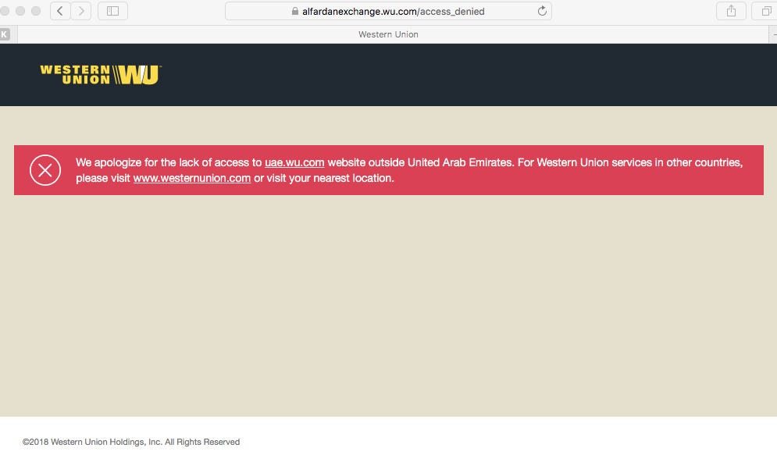
Figure 1: Alfardan Exchange
Therefore, UAE Exchange can use its influence, innovation, and professional technical team to overcome this issue, and become the main service provider.
Another challenge is the effects of the GFCs which affected the GPB and hence remittances were low. UAE Exchange has also suffered from stiff competition from other firms in the industry and including the banks that have since offered free remittances, if both accounts were from the same banks. This has reduced the sales and even the growth rate of the firm. The key resources, activities, functional areas include strong leadership which has served to create a difference in the industry. Therefore, some services from the banks should be initiated within UAE Exchange, for example, Money Order transactions are similar to the concept of checks; however, they can be generated from UAE Exchange to have high level of authenticity. This will keep the company in an equal pool of services to compete in.
Weakness and Opportunities
Improvement in decisions capabilities of the company will help enhance decision making capabilities. Decision ought to be made and within the standard time limit to ensure that the firm is able to exploit the emerging markets. Reputation of the company might prevent the firm from effectively expanding into the emerging markets and thus to rebuild the reputation, the companies should present itself in emerging economies as one that involves ethics in its operations. This would be achieved through communicating and openly conveying the financial reports of the company, this is achieved through releasing annual reports and this will help in regaining the company’s reputation. Also, UAE Exchange could market itself through e-currencies to support local market. For example, it will mean that it stands against “Double Spending” which is an issue in money transaction that could be solved with digital currencies, therefore, it will help gain its reputation as it stands against fraud.
Weakness and Threats
The company is accused of money laundering especially from employees which has negatively impacted on the company reputation. The immense indecisive nature of the company, can enhance coming up with strategies that will help in enhancing decision making. This will enhance the competitive advantage of the company, through making decisions that are strategic in nature. One of the major alternatives that would enhance strategic decision making is employing the use of Customer Relations Management(CRM), which enhances tracking marketing trends and thus coming up with effective decisions.
In addition, the company must follow new trends in the market and update its website and mobile app with newly accustomed services. The mobile app should have the ability to integrate with e-commerce markets, or even e-market that uses digital currencies, where UAE Exchange could be an authenticated third party.

2.5 Critical assessment of Strategy

Strategic Direction of the Company

UAE Exchange is using a strategy of related diversification which means that the company is diversifying only in the same business and industry. The choice by using the organization to open some other sea outlet could be seen as a chunk of a sweeping whole deal fundamental improvement method which the UAE has been completing in the midst of the beyond couple of years. The UAE is the second one country inside the GCC to make utilization of its land inclinations of having multiple sea retailers. Since the mid Nineteen Eighties, Saudi Arabia has prolonged its toll/import decisions through making actual ports at the Arabian Gulf and the Red Sea seashores.
The Arabian Gulf-Red Sea pipeline crossing A Saudi region from the West to East gave an epic ideal function and versatility by way of empowering Saudi oil to be conveyed from two essential shops organized in out and out amazing land zones. The benefit of having two operational sea outlets ended up being clean inside the midst of the essential Gulf War whilst Saudi Arabia could maintain up a segment of its oil deliver via its Red Sea pipeline. The tanker war in the Arabian Gulf waters in the midst of the Iran-Iraq war made the seaborne toll of oil a volatile and immoderate business. Reestablished risks of impedance with the hazard of route through the Strait of Hormuz via sure not unusual states and with the aid of non-nation on-display characters, frequently intellectual activist social affairs, consists of real pressure for all oil-conveying Gulf States.
The beginning of the ocean base through the UAE must be seen as a noteworthy a part of a greater extensive direction of action of widening and of mooring its important status quo and essentialness supply. In the not so distant past, the organization announced its selection to vicinity property into an oil gathering terminal at the Fujairah port and constructs the USA's most outstanding power and water remedy plants. Moreover, the China National Petroleum Corporation is building a 400 km pipeline that will installation the ability to transport 1.5 m/b of oil from the Habshan oilfield inside the southwestern bit of the emirate of Abu Dhabi to the Fujairah bring terminal, retaining up a crucial separation from the Strait of Hormuz if integral.
Disregarding the manner that the UAE movement to make use of the ocean outlet within the Gulf of Oman has come to some diploma past due, it is a goal and fundamental improvement to expand and develop the USA's import and fee capacities. Exchanging oil thru the Fujairah seaport could have interaction tankers to steer clear of the Strait of Hormuz. This elective course isn't always sincerely less costly besides is extra at ease for tankers. At the factor while all is stated in achieved, enthusiasm for some other sea outlet will decrease the UAE economy's frailty to conflicts undermining the USA's imperativeness admission and update its unity to outside weight.
Money Transfer/ Remittances Strategy

The UAE recorded a 17.30% increase in remittances YOY in the 1st quarter based on the Central Bank data. A surge in the activities is due to many reasons. For example, the country has an economic stability due to stable prices of oil. The next reasons are the desirable sentiments due to the policy recently announced by the UAE government that additionally enhanced the non-oil economy. Also in the list are the forecasted tourism and trade numbers in the run-up towards Expo 2020. With this growth in the economy, there is a corresponding surge in the remittances. The final reason is the string dollar as several Asian currencies remain under immense pressure and hence there is a surge in remittances.
The UAE Exchange has engaged in acquisition as a strategy to boost its performance. For example, UAE Exchange remains part of the Finablr company network and it comprises of several brands in financial services. This strategy was declared in the year 2015 immediately the Dr B. R Shetty had acquired Travelex. It stood as a scale acquisition since then the UAE Exchange wanted global presence. Following the acquisition the company’s investment stressed on capabilities enhancement. For instance, the firm acquired Remit2india with a strong digital money transfer capability from the UK, US, Australia and Canada, mainly into India. Simultaneously, the firm invested in Swych which was a digital cross-border gifting services firm, Dubai-based Souqalmal as well as Loyal which was a blockchain-oriented loyalty firm.
UAE exchange used the tie-up with blockchain firm Ripple with an expectation as a strategy to explore the settlement, transfer and reconciliation messaging. This came after the firm realized that money transfer remained on a 2-speed world whereby messaging takes places in real time, whereas settlement took an extended period. Therefore, the strategy to adopt such a technology was meant to allow the UAE Exchange to provide competitive services because it has an influence on both transactional speed and cost.
The firm has also been involved in rebranding exercise as an important strategy to boost its sales. This was declared in April this year that the firm intended to bring its financial services under the Finablr. Therefore, as a constituent of Finablr strategy, the Company’s operations away from UAE have been changed to undertake their operations under the brand, Unimoni. This name covers twenty-two markets around the globe. The primary reason for this strategy is that the type of services offered by UAE Exchange and its customers being served has undergone significant evolution. Therefore, Unimoni revolves around the money universality, however, the firm was equally proud regarding equity and legacy it has in the United Arab Emirates. Therefore, the company adopted a strategy to remain operational in UAE as UAE Exchange, but as Unimoni in foreign countries.
In respect to its association with FinTech Hive, Dubai, the company also has a plan to leverage the fin-techs. This is based on the realization that the globe has become borderless. Therefore, the company has seen it imperative to collaborate as well as work with fintech start-ups which has been a motivating exercise to the Company. The firm has also partook significantly in programmes of FinTech and offers mentorship to certain start-ups and this makes the Company to attract more clients.
Also, the UAE is aware of how the remittances industry is poised to evolve in the ten years. Therefore, it recognizes the potential digital proliferation as a key trend and hence it is adapting to this possibility much ahead of its competitors. Moreover, the firm is aware of the AI, big data, blockchain and machine learning will improve its efficiency and hence is already integrating all these in its operation to create a sustained competitive edge. The company also uses the collaborative mindset as the basis of its remittances strategy since it is aware that when the institutions collaborate and come together, there is a potential to acquire novel means of doing things that make the firm to gain additionally (Sainaghi, Phillips & d’Angella, 2019).
The firm has also enhanced its partnership to ensure instant money transfer. For example, it partnered with WorldRemit in the year 2016. This saw Abu Dhabi and London partnering on 10-05-2016 to provided WorldRemit customers or clients instant money transfers for a diverse market. Via this partnership, the customers of WorldRemit can hence send money instantly and get picked up as cash at any branch of the UAE Exchange in such countries like Kenya, Rwanda, Zambia, Uganda and Morocco. The firm has since rolled this new service to additional countries in Asia, Middle East and Africa. People now only need to install the WorldRemit App to send instant money to their families and friends in more than 125 different nations. This has improved the growth of the UAE Exchange since the customers of WorldRemit, United Kingdom’s fasted-expanding technology firm, sending more than 400, transfers per month.
The UAE Exchange provided a range of services as well as multiple remittance channels to its clients and customers. Its network of eighty-hundred branches spread across 31 nations makes the firm to have a correspondent banking connections with more than one-hundred and forty global banks. The firm has, via WorldRemit’s Payout API, integrated with WorldRemit to allow it process a high request frequency hence increasing its efficiency and revenues. This is because while WorldRemit benefits from UAE Exchange’s extended correspondent network, and subsequently allowing WorldRemit to expand its coverage into novel regions, the UAE Exchange benefits from the revenue from the WorldRemit customers. This has boosted the efficiency of UAE Exchange since it has been able to give the people the power of sharing their money anywhere and anytime to allow customers to enjoy greater a range of payout options in many countries than even witnessed before.
The firm has also extended its collaboration with Western Union and this has boosted remittance services in Malaysia. By having both UAE Exchange and Western Union, global giants in financial services industry partnering together through a strategic relationship, Money Transfer has been made a seamless experiences especially for Malaysian expats residents. These customers can currently send money via Western Union Money Transfer SM services from any of the 15 UAE Exchange branches situated in Malaysia. Such a tie-up strategy has subsequently strengthened its efficiency over the years starting from Middle East to North Africa, to Europe and currently in Malaysia. Such a multi-channel payout alternatives in destination country of receipt makes the tie-up strategy a key driver of remittance services in UAE. The long-standing association between Western Union and UAE Exchange has built upon the business synergy which continuously evolves around the satisfaction of the clients and customers. This tie-up strategy saw a total remittance volume customers sent home via foreign workers from Malaysia alone amounting to a surge of 23.2 percent to RM 34.750B in the year 2015 from the initial figure of 28.21B in the previous year.
Foreign Exchange Strategies

The UAE Exchange aims at being the most trusted brand in terms of foreign currency services. This is done by ensuring that it provides the best attractive rates than any other competitor. It also uses the strategy that allow people to buy and sell major currencies at over 800 branches globally. This is ensured by assuming a strategy that makes it the best competitive foreign exchange rate provider. To do this, UAE Exchange ensures excellence in customer services. The Company uses a global expansion plan as a strategy to run its foreign exchange wing of the business. It business is based on organic growth. It is aiming at seeing a quicker global expansion in the near coming future.
The firm’s novel global strategy is connected closely to the 1.20B dollars acquisition of the Travelex, Foreign Exchange firm through its shareholders. Whereas both UAE Exchange and Travelex shall continue to stay as two standalone brands, UAE Exchange is working on the best strategy to use synergies of both firms to acquire foothold in the novel markets. This strategy uses same shareholders for both the two firms. They are engaged on novel initiatives to permit full realization of synergies. At the present, UAE Exchange has been growing organically, however, with the acquisition of Travelex, a big boost is guaranteed to its global aspirations. As an independent entity, UAE exchange enjoys large market share in South Asia, Middle East as well as South East Asia. Even though the UAE Exchange is already present in United Kingdom and Europe, the firm its dominant level is still low. However, the firm aims at using Travelex acquisition to change its market share in both Europe and UK dramatically.
Being that Travelex and UAE Exchange leads foreign exchange and remittances business respectively, the firm aims at using this acquisition to stamp its authority in terms of market leadership in both foreign exchange business and remittances. To achieve this, there must be a strong customer base. This has made the UAE Exchange to start working on strategies that will allow it fully use the complementarities of foreign exchange and remittances’ share. The UAE Exchange aims at using a combination of its customer base and those of the Travelex. For example, UAE Exchange customer base is low-to-middle income customers whereas Travelex serves middle-to-high income customers. Therefore, combining these strata will ensure a broad spectrum of the customer base which will ensure the firm benefits from this strategy. This strategy is intended to brig both foreign exchange and remittances under one umbrella through greater integration and ultimate IPO. The UAE aimed at bringing the two business under a holding firm, United Global that was anticipated to go to public by early 2017, subject to clearance by regulatory and conditions at the market.
The UAE Exchange also streamlined the operations as a strategy to implement the acquisition. UAE Exchange maintained the strategy of going public as a single entity, the integration process of the business began. The firm streamlined operations in areas with UAE Exchange and Travelex had operations overlapping thereby enabling the firm to hit maximum efficiency. UAE Exchange remains committed to become dominant participant globally in respect of payments, remittances, and foreign exchange. The UAE Exchange, at ancillary level, has effective plans in place of engaging in other business including banking. Acquiring Travelex came with double banking licenses in countries like Brazil and France. The firm is making efforts to acquire banking permits in India. Based on markets, the UAE Exchange will be examining such business, however, from a global side; UAE Exchange’s core business will remain remittances, payment and forex.
Payment Strategies

UAE Exchange is armed with superior financial services industry experience. This makes the firm support its customers effectively through the provision of best-in-class, comprehensive services and products designed to guarantee convenience, value addition as well as easier payments. This has allowed the UAE Exchange customers to simply get into its many branches and make payment for their respective utility bills, mobile top ups, school fees, subscriptions and airline tickets among others.
In regards to payment of bills, the firm employs a strategy that primarily aims at making customers’ lives increasingly easy and simple. This is executed by offering several convenient as well as accessible means of paying for the insurance, subscription or utility bills at any of its branches. One can easily pay for his electricity bills, schools fees or water bills easily at the nearest branch. Credit card bills can be paid or credit bills settled any UAE Exchange outlets, though it is available only for certain credit cards. Subscriptions are also possible without UAE Exchange whereby a customer is allowed to subscribe to a range of services through payment of amount of such a subscription at any of UAE Exchange branches. For instance, one can pay for Shaadi.com subscription simply by a visit to the nearest branch. The customers have also been given an opportunity to top up their mobile simply by walking into any of the firm’s branches and top for their respective relatives, friends, and their families’ mobile phones irrespective of where they are instantly. The customers also can pay for loan instalments through monthly installment at the nearest outlet of the UAE Exchange. Payment of insurance premium is also made possible by simply executing it at any branch of the UAE Exchange.
UAE also targets the payroll. This strategy uses a SmartPay Payroll Solution designed and developed to ease the process of salary disbursal for corporate entities. This strategy emerges from the understanding that employee payment for their monthly salaries remains a tiresome activity, and thus this strategy aimed at providing professional payroll service by offering a disbursal solution that corporate entities can greatly rely on. Therefore, UAE Exchange has designed and developed a payroll solution that is in total compliance with the Wage Protection System (WPS) directed, commenced in collaboration with the Ministry of Labor and Central Bank. This strategy has attracted many corporate clients to the tune of more than 25,000 and over 3000, 000 customers as beneficiaries from the SmartPay Payroll Solution.

2.6 Key lessons learnt from the past

The UAE has learned various lessons from the past. One of the key lesson is the need for going global through acquisitions and partnership. The UAE Exchange has learned about the benefits that come with global expansions through by acquiring firms and partnering with other firms like Western Union and Travelex. The firm has benefit from such strategies since they have enabled it stamp its authority in the global financial services sector. This has been achieved through increased global network that captures North America, Africa, Middle East, Oceania, Asia, and Europe. Another lesson learned by the UAE Exchange is the need to focus more on clients and customers’ satisfaction through being perceived as a sustainable business. UAE Exchange achieves this through effective loyalty program, “earn, use and benefit”. For this reason, UAE Exchange has been able to create an effective customer base since people like its brand, and give it their trust hence becoming loyal customers. Therefore, UAE Exchange understand the need to give its customers more value in exchange of their trust and loyalty to the company. The firm, therefore, has learned to accomplish this by implementing desirable loyalty programmes in relation to customers’ favorite brand. This has ensure that its brand becomes increasingly flexible, responsive and rewarding.
The firm has also learned that being sustainable is quite rewarding as a leading global foreign exchange, payment solutions and money transfer brand. It has, therefore, remained socially conscious firm. It stays updated in terms of seeking for opportunities to expand its support towards various social causes. The Company, as leading remittance, uses is corporate social responsibility (CSR) wing to work closely with enormous population sector known as immigrants, from various regions of the globe. It is, therefore, involved in awareness activities like medical facilities alongside rehabilitative activities undertaken amongst this segment.
Through, the firm has learned that its customers and community are told the company cares for them. The firm CSR team gives aids to every form and work closely with NGOs dealing with humanitarian and environmental causes globally. It is thus devoted to developing a culture in which employees and stakeholders’ safety is guaranteed to raise any issue regarding any unacceptable or poor practice or misconduct event. UAE Exchange is further committed to the provision of assurance to everyone that any suspected fraudulent acts shall never be condoned and will be probed fully, with immediate preventive and corrective actions implemented and adoption of punitive measures against people proved guilty of such activities.
Competitive Advantage
The UAE Exchange has employed a culture of innovation in a bid to satisfy all the dynamic and ever-changing needs within the financial market. The financial market is experiencing and continues to experience rapid technological innovations as corporations and individuals are finding more secure medium of exchange. The UAE exchange has engaged in innovations that aims at satisfying these particular needs.

Phase 3: Defining the Current Issue(s) and Problem Statement

The main issue facing UAE Exchange is the competition from banks in terms of remittances. UAE Exchange is increasingly feeling the heat since UAE banks are increasingly becoming active to offer free remittance services to respective account holders via online banking. Various local banks in UAE are presently providing free online remittance service thus providing a great challenge to UAE Exchange, which averagely charges between Dh16 and Dh22 to remit funds. Abu Dhabi bank, for example, runs a mobile and online banking remittance service for unlimited free global transfer for currencies.
Asian countries also benefit from free and direct remittances offered by Emirates NBD via mobile and online backing within sixty seconds. Additionally, other banks are running promotions as well as offering free transfer of money to expatriates. The introduction of VAT in January 2018 in UAE has made online remittances to gain increased momentum from expats, which comprise over 8M of the population of the UAE. Thus, it increasingly become a challenge for UAE Exchange as banks go digital and subsequently offer free remittances.
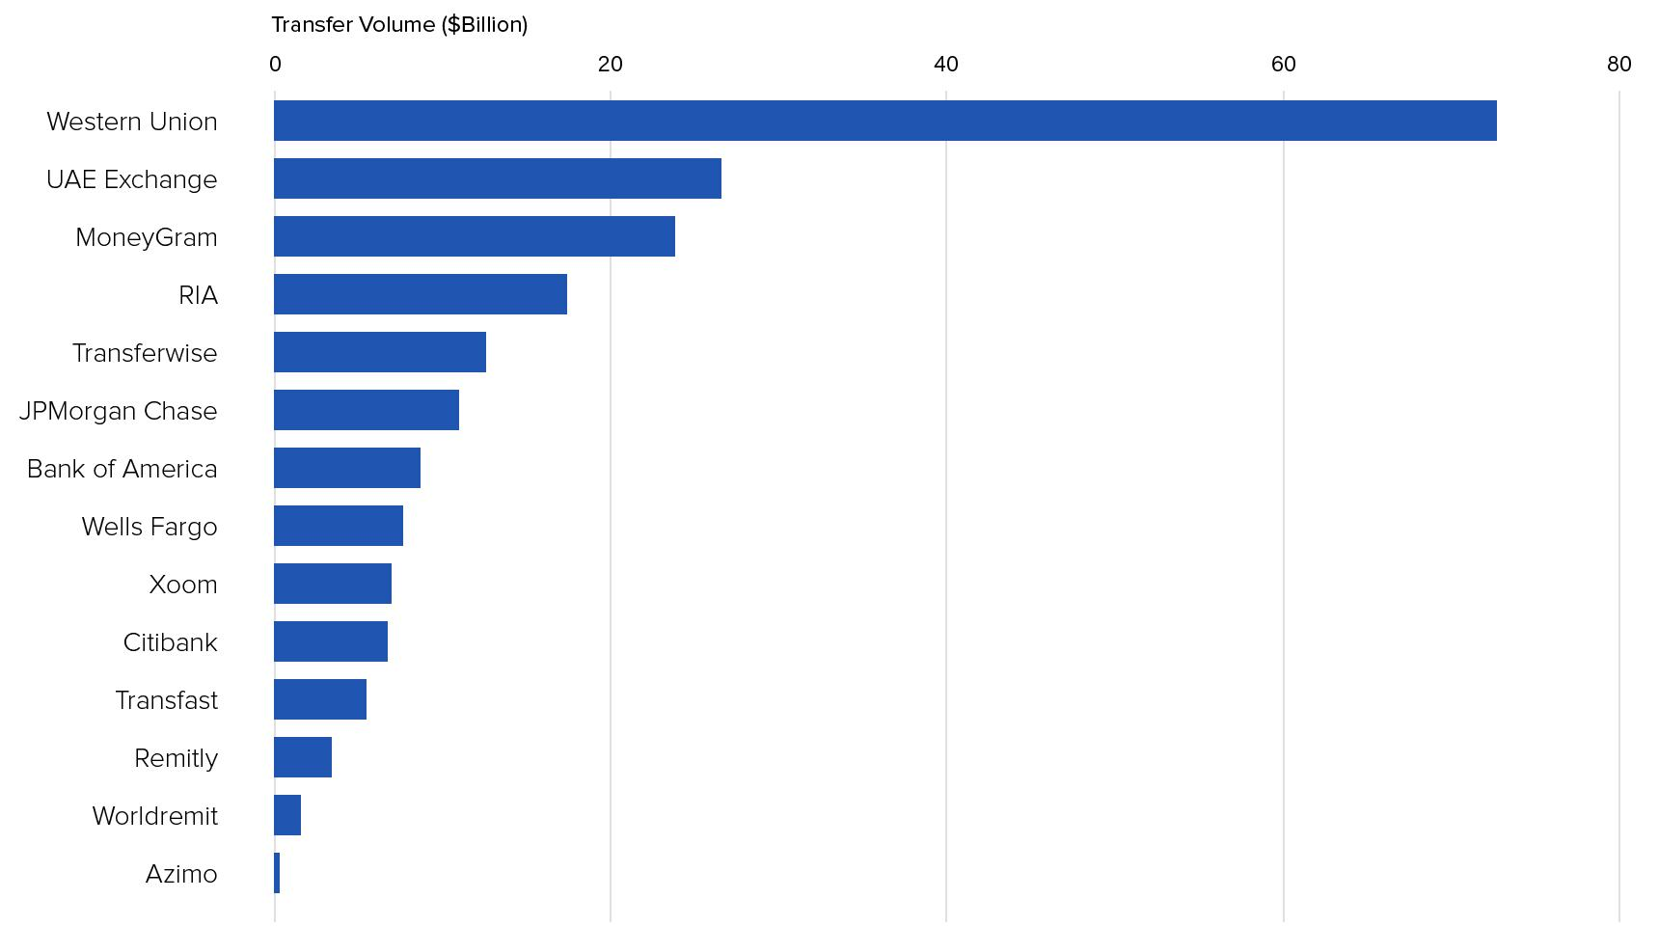
Figure 2: Cross-Border Money Transfer Volumes by Company (TTM August 2017)

The challenges have thus surged for UAE Exchange remittance wing to thrive since UAE Exchange business is also dependent on banks to survive. This is because banks remain a key lifeline for UAE Exchange. Without banks to partner with, the future of remittances through UAE Exchange seems extremely challenging. This is because the UAE is compelled to pass the VAT cost on remittances fees to its customers which might in essence render the remittance business ineffective. With full implementation of free remittances to banks, UAE Exchange will start to lose revenues since remittances is a major contributor of its revenue.

Profitability and Customer Satisfaction
The factors influencing people to choose the UAE Exchange are speed, safety, reliability and friendly service. As previously mentioned, there are certain problems that have an impact on the UAE Exchange in terms of profitability, number of transactions and customer satisfaction. As shown in figure 1, one of the reasons why UAE Exchange ranked second in money transfer volume is because UAE banks became active in offering free remittance services to individual account holders. Another reason is the introduction of VAT in January 2018, which increased the service cost to the consumer resulting in more customers choosing UAE banks instead of exchange centers. Because of those reasons, profitability of the UAE Exchange has been affected.
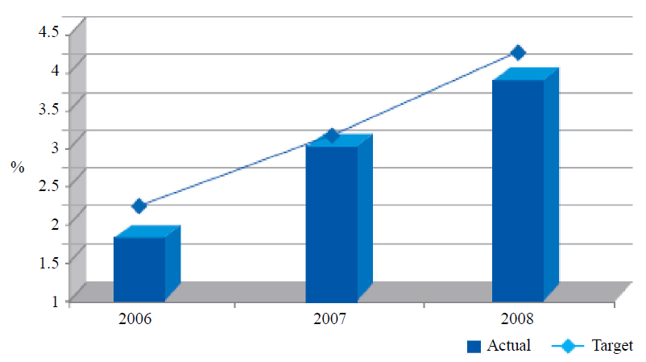
In addition, to be an effective and efficient business center, it requires for UAE Exchange to focus on 3Ps: people, product and process. UAE Exchange has a strong growing position in the market share, as shown in figure 3 (Shah & Joseph, 2011). To maintain their position, UAE Exchange should focus on their customers in order to be the leading exchange company.
Figure 3: Market Share

Phase 4: Analyzing Information
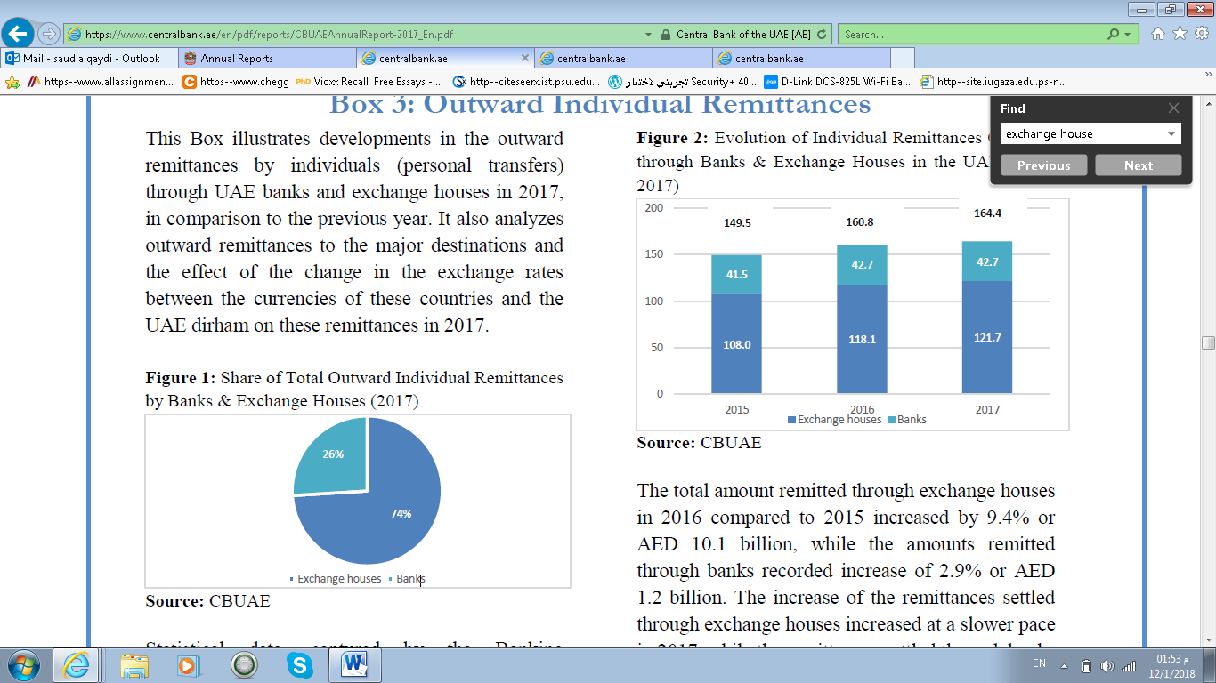
From the above figures 4 & 5( C. B. (2017). The money transfer captured by Central Bank of the UAE shows in 2017, UAE banks and exchange houses combined
at AED 164.4 billion. The percentage of remittance through banks 26% (42.7 billion) and 74% of remaining remittance were through the exchange houses (121.7 billion). However, when VAT applied by UAE government in 2018 to remittance services and other money services like exchange foreign money rate. There is no doubt that UAE banks are increasingly offering free remittances since they also need to compete with the exchange houses to attract more account holders. This strategy by the banks will deduct a huge chunk of revenue from the exchange houses including the UAE Exchange. It is critical for UAE exchange to enhance differentiation that is although the services provided are secure, there is need to maintain consistency especially with regards to the confidence of the clients. This means that they need renewed confidence with regards to the confidence of the company and therefore would enhance confidence and thus be able to survive in the competitive business environment. Corporations like PayPal for instance have already gained roots in emerging markets like Africa and this is a significant challenge for UAE since penetrating in this kind of market might be a challenge for the company because of well-established corporations in this market like PayPal and Western Union.
Figure 4: Evolution of Individual Remittances Outflows through Banks & Exchange Houses in the UAE (2015-2017)
Figure 5: Share of Total Outward Individual Remittances by Banks & Exchange Houses (2017)

Phase 5: Generating Alternatives

- From the above problem, UAE exchange needs to continue diversifying its business in other countries whose banks do not offer the free remittances. Through this alternative, the UAE exchange will be able to compensate the lost revenue in UAE due to free remittances by banks.
- Another alternative is for UAE exchange to consider entry into the banking sector to diversify its product portfolio and compete the banks in what products and services banks offer.
- The third solution is for UAE exchange to negotiate with other exchange houses and form a strong voice that can then be used to negotiate with banks to halt their involvement in free remittances.
- Fourthly, the company’s logo says, “Service is our currency” and without customer satisfaction there will be no services. Satisfying customers will bring employee satisfaction, hence, the profit maximization of the company. The new challenge that lays on UAE Exchange is lowering the price of services offered.

Phase 6: Recommended Strategies, Evaluation & Control

To decide the best strategy, the UAE Exchange should focus on knowing the competitive advantages, which are addressed in PESTEL analysis, knowing their customer and by differentiating their products. As discussed above, the firm’s position within the industry is determined by the firm’s profitability. To maintain a sustainable competitive advantage for UAE Exchange, several types of business level strategies can be addressed: low cost or differentiation. There are three ways to achieve the desired performance within the two strategies: cost leadership, differentiation and focus (cost focus or differentiation focus). Other type is corporate level strategies which includes integration and diversification.

6.1 Business Level Strategies

6.1.1 Cost Leadership

To become a low-cost producer in the industry, UAE Exchange can pursue an economy of scale, technology and access to different raw materials.
- To compete with the banks, UAE Exchange can reduce their expenses and liabilities by adding transaction machines. In order to get a high number of transactions or currency exchanges, UAE Exchange can study geographic locations and target their customers.
- Another way is to create an app for sending cash quickly between friends and family by simply linking to their contact list. The money will go directly to their bank account which will cost 1% of the value or a minimum of AED 1 (whichever is higher) for one transaction; easy, simple and fast.
- Currently, in exchange centers, the unit cost of each transaction is the same, regardless of quantity transacted (Farnham). In order to achieve a low-cost strategy, UAE Exchange can offer a different fee structure where if the customer transacts money above a certain amount, they can get a discount on that transaction.

6.1.2 Differentiation

In differentiation strategy a firm seeks to be unique or have the ability to provide a superior value to the buyer in terms of product quality, efficiency, special features or after sale service. The below points are some strategies that can be followed.
- Product quality: defined as a value of a product or service to the customers.
The first activity or objective is communication and information. Communication plays a big role in quality where it can reach to the customer’s heart. UAE Exchange could offer several courses for their employees to achieve a high quality of communication. For example, courses in communication skills, public relation and body language. In addition, offering a position for an employee who can speak to special needs (the deaf or blind) or speak different languages.
- Efficiency: UAE Exchange can achieve efficiency by opening more counters in rush periods; high speed of services.
- Special features: the benefit of having special features is to differentiate the business from other competitors. For example, offering a new call center which will be available 24hrs for the customers, either solving issues or helping with new transactions.

6.1.3 Focus

To solve the discussed problems, cost focus will be an appropriate choice to implement by targeting the customers.
- A solution would be to offer a loyalty program that allows customers to earn points for using UAE Exchange services. For example, transferring a certain amount of money or using services earns points to be redeemed for entertainment, leisure, shopping, movies, tickets etc.

6.2 Corporate Level Strategy

Corporate strategy refers to the selection of the firm as whole and the management of its business or product portfolio.

6.2.1 Diversification

UAE Exchange follow corporate strategy of related-linked diversification, UAE Exchange organized to provide 5 services: bill payment, wealth management, repaid card, loyalty program of customer and smart buy. All five services provided by UAE Exchange center under one celling. Related diversification strategy takes place when a firm expands their services into a product line. UAE Exchange has a strong advantage from related-linked diversification strategy which spread their risk into different product line. When more than one service is offered or developed in a company, economies of scale can be achieved by eliminating certain expenses.
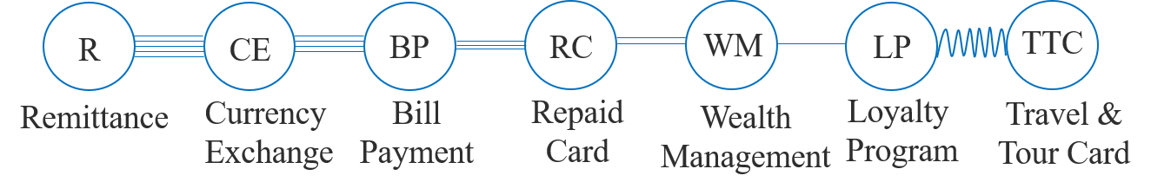
- For a new service, UAE Exchange can offer a new travel and tour card where they can attract new customer, figure 6.
Figure 6: Related-Linked Diversification

6.3 Green strategy

One way to help the firm address the above problem is to employ the green strategies. The UAE Exchange needs to focus its activities of CSR in order to be perceived by the clients to be more concern about them. In so doing, the business will be able to retain its clients since these clients will be able benefit more and agree to continue doing business with UAE Exchange.
By going green, UAE Exchange, they will play a pro-active role in consider ecological and environmental aspects as integrant constituent of their money transfer or remittance principles. Through this, UAE Exchange will provide personalized money transfer services while promoting sustainable money transfer principles.

6.4 KPI and Balance Scorecard

Table 5: KPI & Balance Scorecard
Dimension | Objectives | KPIs
Internal Process (IP) | IP_O_1: Increase staff productivity  IP_O_2: Reduce queue length  IP_O_3: Innovation  IP_O_4: Expansion | IP_O_1: Number of transactions with the help of Lobby Managers.  IP_O_1: Number of annual leaves at the end of month.  IP_O_2: Percentage of queue length down  IP_O_2: Duration of time standing in queue  IP_O_3: Number of technologies used to serve customers.  IP_O_3: Number of OS integrated with customer services  IP_O_3: Duration of transaction collections  IP_O_4: Number of branches  IP_O_4: Number of sponsorships
Financial (F) | F_O_1: Increase remittance 10% in 2018 | F_O_1: Number of remittances.  F_O_1: Number of anti-immigration laws.
Customer (C) | C_O_1: Customer loyalty  C_O_2: Customer satisfaction | C_O_1: Number of customers in loyalty program.  C_O_1: Number of transactions from same customer.  C_O_2: Number of satisfaction surveys.  C_O_2: Number of complaints
Learning and Growth (LaG) | LaG_O_1: Increase employee morale  LaG_O_2: Employee satisfaction  LaG_O_3: Employee training program | LaG_O_1: Number of suggestions made by employees  LaG_O_1: Absence from unethical report listing by UAE central bank.  LaG_O_2: Percentage of compensation for daily work  LaG_O_2: Employee Net Promoter Score  LaG_O_3: Time for each transaction  LaG_O_3: Training Net Promoter Score

The key decision criteria will be for UAE Exchange to continue partnerships and collaboration with banks and organizations that have adopted green banking. Through, this will be able to appear more sustainable and keep the growth of their customer base.
The evaluation and control will be done using new balanced score card. For example, since the strategy aims at convincing the client or customers to stay with UAE Exchange, the aim is to determine how much value UAE Exchange Green Strategy creates in the eyes of these customers by measuring the customer loyalty and market shares. This measure can be done by having the firm focusing on the customer quadrant which has the objective of delivering for customer (El Bodan, Aga & Alrub, 2017).
The control will be based on these quadrants to see whether the organization is improving after implementing this green strategy by measuring the market share and customer loyalty.

Phase 7: Conclusion, References & Appendices

7.1 Conclusion

The paper has analyzed the UAE financial services and insurance industry through a case study of UAE Exchange. The performance of UAE and the industry has been analyzed. It has been shown the UAE Exchange performs above the industry average in terms brand intimacy. UAE Exchange is a leader in the industry in terms of foreign exchange, money transfer and payment solutions. It uses various strategies to create sustained competitive edge both locally and globally.
However, it is discovered that the major issue facing the UAE Exchange is the competition from banks that offer free remittances, and this will affect the UAE revenue. Nonetheless, with UAE Exchange going green, it will help compete in the industry by being perceived to be more concern for its customers who will not want to quit to get served by banks. The new balanced score card will be used in evaluation and control to measure whether the strategies is a success or failure.

7.2 References

El Bodan, M., Aga, M., & Alrub, A. A. (2017). Impact of Corporate Governance and External Audit on Earning Management. Evidence from the Financial Sector of United Arabs of Emirates (UAE). International Journal of Finance and Accounting, 6(6), 172-178.

Paltrinieri, A. (2015). Stock exchange industry in UAE: An assessment of potential merger between Dubai financial market and Abu Dhabi securities exchange. International Journal of Emerging Markets, 10(3), 362-382.

Rabbani, A., Zamani, M., Yazdani-Chamzini, A., & Zavadskas, E. K. (2014). Proposing a new integrated model based on sustainability balanced scorecard (SBSC) and MCDM approaches by using linguistic variables for the performance evaluation of oil producing companies. Expert Systems with Applications, 41(16), 7316-7327.

Sainaghi, R., Phillips, P., & d’Angella, F. (2019). The balanced scorecard of a new destination product: Implications for lodging and skiing firms. International Journal of Hospitality Management, 76, 216-230.

Shah, J., & Joseph, T. (2011). UAE Exchange Centre LLC: business level strategies. Emerald Emerging Markets Case Studies, 1(1), 1-9. doi:10.1108/20450621111110384

Porter's Generic Competitive Strategies (ways of competing). (n.d.). Retrieved from https://www.ifm.eng.cam.ac.uk/research/dstools/porters-generic-competitive-strategies/

Farnham, M. (n.d.). Why Do Cities Exist?. Retrieved from http://web.uvic.ca/~mfarnham/temp312_pdfs/T2_notes_whycities.pdf
C. B. (2017, December 31). Annual Report. Retrieved from https://www.centralbank.ae/en/pdf/reports/CBUAEAnnualReport-2017_En.pdf

